Software Requirements Specification

for



**Version 2.0**

**Prepared by**

**Team Phoenix**

|  |  |  |
| --- | --- | --- |
|  |  |  |

**Revisions**

|  |  |  |  |
| --- | --- | --- | --- |
| **Version** | **Primary Author(s)** | **Description of Version** | **Date Completed** |
| 2.0 | Team Phoenix | The final version of the SRS document has been drafted with all the requirements being incorporated into the document. | 12/02/13 |

Table:1

# 

# 

# *.*

# 

# 

# Introduction

## 1.1 Document Purpose

The product whose software requirements are specified in this document is Event4u .

The purpose of this document is to present a detailed description of the product, Event4u . This document is intended to

* Explain the purpose and features of the product, Event4u
* The constraints under which the product must operate
* How the product would respond to different users’ requests.

The document’s primary goal is to help the reader get a better understanding of the project.

The document is intended for the developers of the software, the end users of the product who have been identified in the later sections, and to the professors who would review the project.

## 1.2 Product Scope

The software being developed is a web based event management centre. The product would simplify the whole process of organizing an event by

* Helping the event manager divide the co-organizers or volunteers into different teams.
* Allocating different tasks to the teams.
* Providing different views of the software depending on different roles.
* Implementing a feature to provide the event manager the ability to track the expenditure while the whole planning process is taking place.

The points mentioned above would greatly simplify the work of an event manager and would let him concentrate more on the finer aspects of the trade. The software will be designed to maximize the event manager’s productivity by providing tools to assist in automating the process of dividing the manpower into appropriate teams. The software also helps in coordinating between the event managers, team heads as well as the volunteers and supervising them, which would otherwise have to be performed manually.

## 

## 1.3 Intended Audience and Document Overview

**1.3.1** **Intended Audience:**

This document is primarily intended for the:

* Developers of this software
* Software engineers who would work on further development of the project
* The professors who would review the document and finally,
* Clients that is novice or professional event managers, volunteers.

**1.3.2** **Document Overview:**

The first chapter, that is the Introduction section of the document is intended to introduce the reader to the product, Event4u.

The second chapter, Overall Description section of SRS v2.0 document provides an

overview of the overall functionality of the product. It describes the informal requirements.

The third chapter, Specific Requirements section, of SRS v2.0 document is written primarily for the developers and describes in technical terms the details of the functionality of the product.

The second and the third chapter of the document describe the same software product, but are intended for different audiences and thus use different language.

## 

## 1.4 Definitions, Acronyms and Abbreviations

|  |  |  |
| --- | --- | --- |
| 1 | Employer | Employer is an individual who has contacted the event organiser. |
| 2 | Event Manager | Event Manager is an individual who is responsible for the whole event and can view the entirety of the event being planned on the software. He/She is usually the lead event organizer. |
| 3 | HTTPS | HTTPS stands for Hypertext Transfer Protocol Secure. This protocol is a widely used communications protocol for secure communication over a computer network, with especially wide deployment on the Internet. |
| 4 | OpenID | OpenID is a decentralized single sign-on authentication system for the Internet. The goal of the OpenID initiative is to allow users to log in at websites around the Internet with one ID, instead of having to create multiple unique accounts. |
| 5 | SRS | SRS stands for Software Requirement Specification. It is a document that completely describes all of the functions of a proposed system and the constraints under which it must operate. |
| 6 | Team Head | Team head is an individual who is responsible for all the actions undergoing under his/her team. |
| 7 | UI | UI stands for User Interface. It is defined as the space where interaction between humans and machines occurs. |
| 8 | View | View means to display and look at data on screen. |
| 9 | Volunteer | Volunteer is a person who offers to take part and help in organizing the event. |

Table no:2

## 

## 

## 1.5 Document Conventions

Formatting Conventions:

* The font style for the headings of each section is Arial Bold and the font size is 18.
* The font style for the headings under each section is Arial Bold and the font size used is 14.
* For the remainder of the document, the font style is Arial and the font size is maintained at 11.
* Italics has been used to indicate comments.
* The text is single spaced and margins are maintained at 1’’ separation.

## 1.6 References and Acknowledgments

**1.6.1 References:**

* [ww.djangoproject.com/](https://www.djangoproject.com/)
* [www.python.com](http://www.python.com/)

**1.6.2 Acknowledgments:**

We would like to thank Mr.Abhishek, Mr.Harsh Golyan, Mr.Prathik and Mr.Rakesh Kumar for sharing their experiences of organizing an event with us. We have gained a lot from their valuable input. A special mention to Mr.Ananth Raman sir for advising us about the different frameworks available and helping us decide the framework most suited for the software, event4u.

# 

# *2.* Overall Description

11

## 2.1 Product Perspective

## A description...

Fig 2.1

The proposed software, Event4u is a new self contained product. The software, Event4u will gather information about various arrangements that are needed to be done to conduct any event by the client. The software will empower the user, be it a professional or a non professional person to efficiently manage any event at hand. The software,Event4u is intended to define a development methodology for the user, beginning with the requirements phase and continuing through to the execution phase.

Every user who wants to use the software,Event4u will have a login to facilitate security and privacy. A simple UI will aid the user in easily navigating through pages and focussing on the task at hand.

There will be 4 views of the overall event:

* Event Manager
* Volunteer
* Team head
* Employer

The software, Event4u will implement the following functionalities :

* Tracking of the expenditure.
* Allocate teams, volunteer.
* Allocate tasks.
* Track the details and developments made by all teams.

An important attribute of Event4u is its independency from the kind of Operating System that the computer on which it runs, as it executes on a system independent browser. In no case is the installation of any other program required for Event4u to work. Event4u is a standalone application. Event4u does not require installation and does not modify the host system.

## 2.2 Product Functionality

These are the major functionalities of the software, Event4u will achieve:

* Provide different views to the user depending on his/her roles.
* Divide the available manpower into teams.
* Appoint a Team Head.
* Allocate different tasks to teams.
* Track expenditure.

## 2.3 Users and Characteristics

The system will support four types of user privileges:

* Event Manager
* Team Head
* Volunteer
* Employer

The various users that we expect the software to be used by are:

|  |  |  |
| --- | --- | --- |
| 1. | Professional Event managers | Professional Event Managers are individuals with prior experience on organizing events. |
| 2. | Novice Event Manager | Novice Event Manager is a first time event organizer who has been entrusted with the responsibility of organizing an event. |
| 3 | Team head | Team head is an individual who is responsible for all the actions undergoing under his/her team of volunteers. |
| 4. | Volunteers | A volunteer refers to the manpower available to the organizer for helping him organize the event. |
| 5. | Employer | Individual who has contacted the event organizer. |

Table no:3

All the above mentioned users are assumed to have a minimal knowledge of the technical aspects of a software product.

## 2.4 Operating Environment

The software will be designed to work on any version of Windows, Linux (kernel 2.7 and above) and Mac platform. The software is completely web based and runs on popular web browsers namely firefox, chrome, internet explorer ( IE8 and above). These web browsers are preferred since they support HTML.

## 2.5 Design and Implementation Constraints

We have to design different pages for different types of users such as event manager, team heads, volunteers and the employer. The implementation part is yet to be done. But, we have a clear picture as to how our pages would look. The communication protocol will be http. There are a number of tools which can be used for its implementation. The maximum number of users at a time is yet to be decided.

## 2.6 User Documentation

No tutorials have been developed as of now.

## 2.7 Assumptions and Dependencies

**Assumptions**

The user is familiar with internet and web based software like social networking sites*.*

The browsers which the user is using is either GoogleChrome 10.0 and above or Mozilla Firefox 4.0 and above.

***3.* Specific Requirements**

## 

**3.1.** **External Interface Requirements**

### 3.1.1. User Interfaces

The user interface design is simple and clear. One can very easily view the events which he/she is a part of and can advertise his/her events on the homepage. In this software, Event4u an individual can create a new account to get access to the website and can organise an event using the provided create event option. An user can select the teams which are required. The view is different for all the actors. Event manager organises the event by assigning work to team members and volunteers.

**Sample Screenshots:**

**Home page**

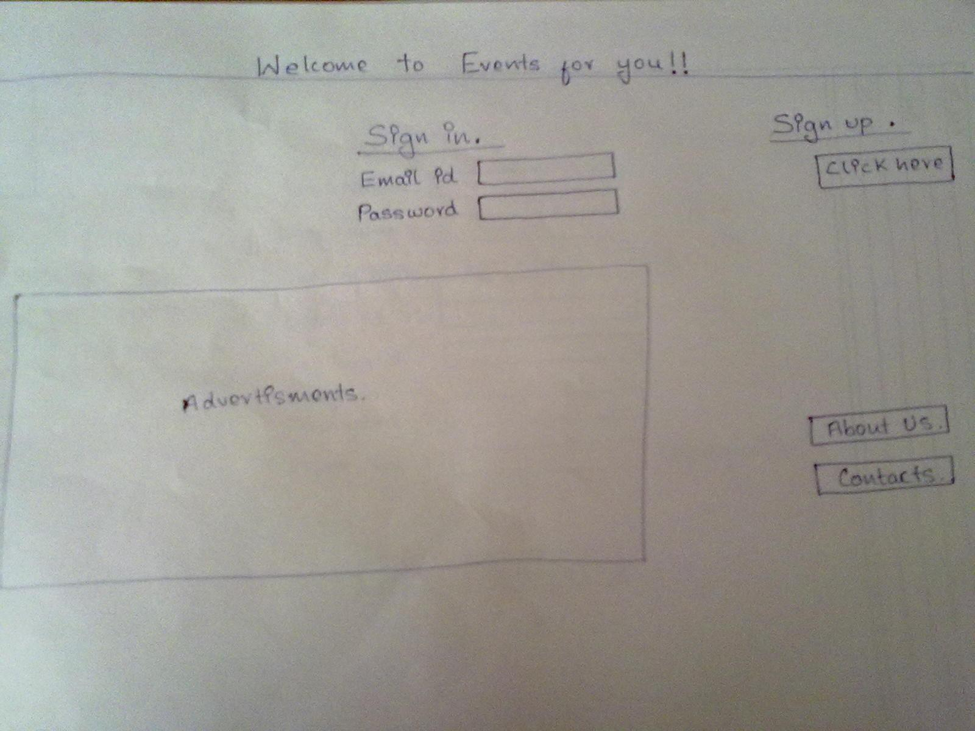

Fig 3.1.1 (a)

**Manager View**

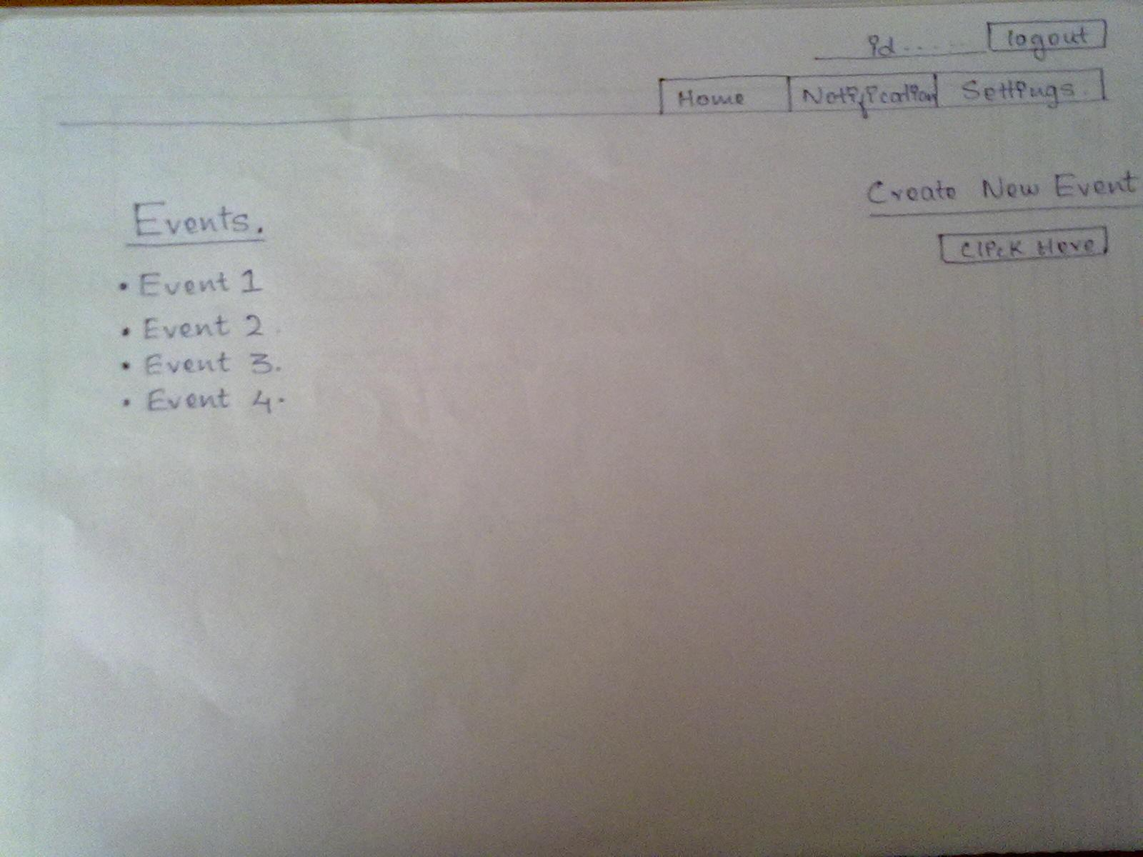

Fig 3.1.1 (b)

**Team Head view**

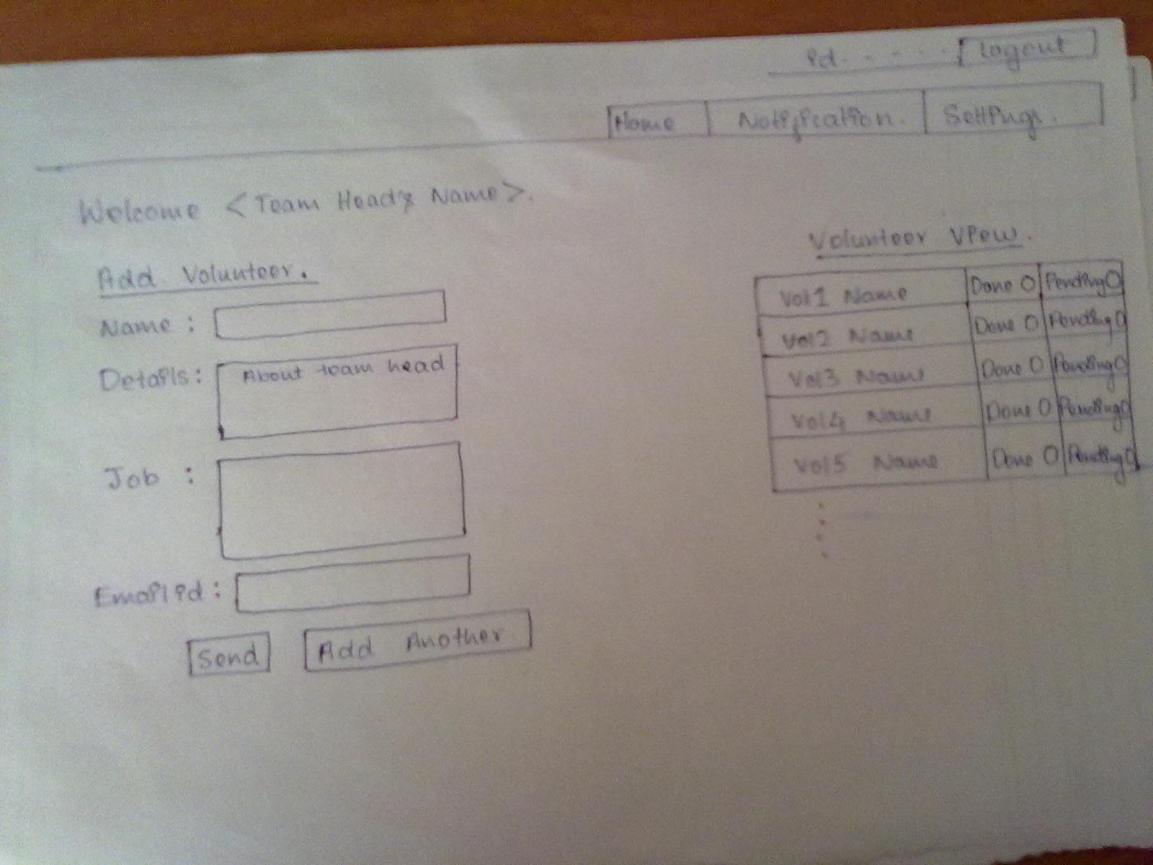

Fig 3.1.1 (c)

**Todo list**

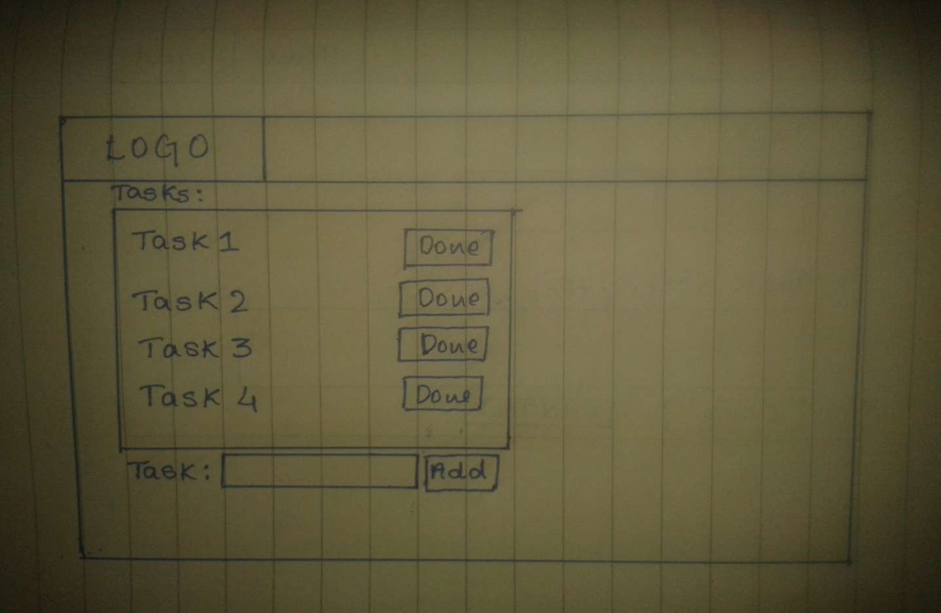

### 3.1.2. Hardware Interfaces

Not applicable.

### 3.1.3. Software Interfaces

### The software is operating system independent. It would run on Linux, Windows and Mac.

### 3.1.4. Communications Interfaces

A web browser is a basic necessity for the software to be deployed. Authentication is done by OpenIDwhich uses HTTPS for security.

## 

## 

## 

## 3.2. Functional Requirements

The web-based Event4u being developed is generic. It can be used to manage any type of event, be it customized events or event types that are provided as templates:

* Event Creation:

Event4u would be able to create customized events and event types to match the requirements. Some of the most common events would be bundled in the database, but it would be very easy to add new ones if needed.

* Task and Team Management:

Tasks are the small pieces that build up a whole event. The event manager would create teams and group the staff into teams, and assign individual tasks to people involved in all the phases of the process, from event planning to event completion.

* Budget:

Inside every organization, budget control is one of the key features for success. The event manager would define maximum amount of money to be spent, and accordingly track the amount of money spent .

* Automatic notifications:

Notifications would be defined to keep all the team members informed about the important appointments or tasks that are pending. Notifications would also be helpful in establishing collaboration between two different teams if their tasks are dependent.

## 3.3. Behavior Requirements

### 3.3.1 Use Case View

4 actors have been identified for the product, Event4u , and each of them are shown with their own set of use cases.

The actors are depicted as stick figures in the use case diagram.

An overall system view of the software, Event4u is depicted with all the actors and their corresponding use cases put together.

All the events would have to proceed with a Login. The other events are self-explanatory as shown in the use case diagram.

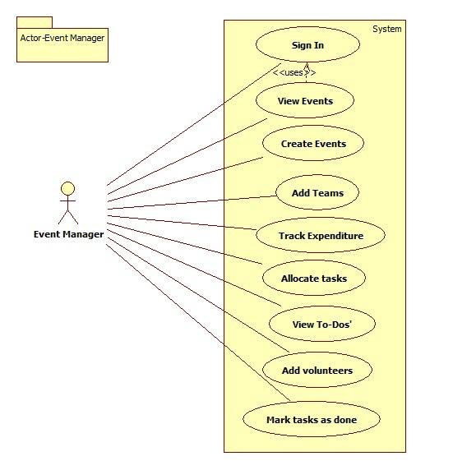

Fig 3.3.1 (a)

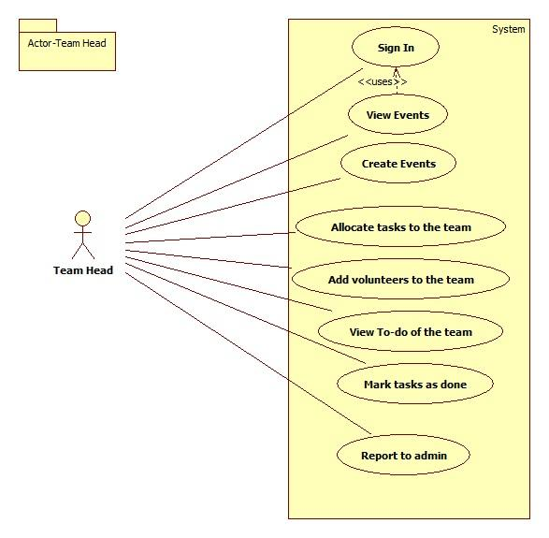

Fig 3.3.1 (b)

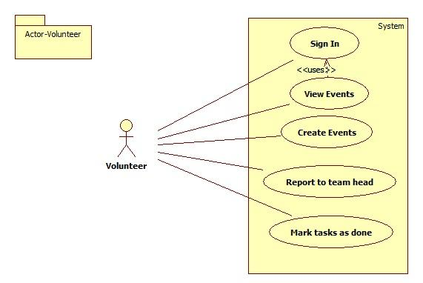

Fig 3.3.1(c)

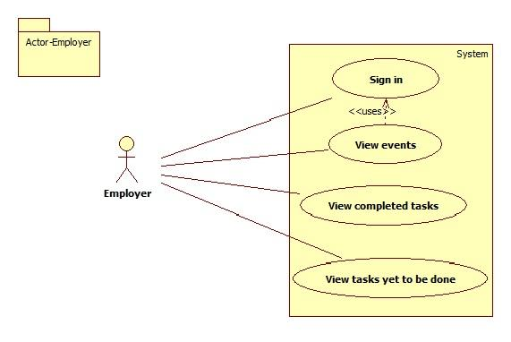

Fig 3.3.1 (d)

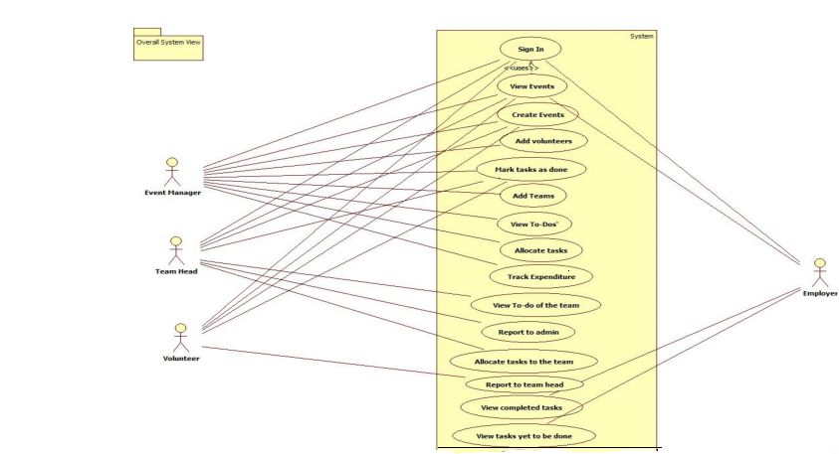

Fig 3.3.1(e)

# *4.* Other Non-functional Requirements

## 4.1. Performance Requirements

* Any transaction will not take more than 10 seconds.
* Multiple users are supported.

## 4.2. Safety and Security Requirements

* The user has to login using the secure OpenID.
* Expenditure details are viewable only to the Event Manager.
* A log file about server activity must be maintained for better crash recovery and security.

## 4.3. Software Quality Attributes

The software will be built on a popular python based framework called Django, which follows Model Template View principle. Since the business logic, presentation layer and database layer are 3 independent entities bound by together by application logic it is easy to add more features in the future.

Due to the MTV structure of the framework, Django, the product is easily maintainable.

That is, one can avoid ripple changes throughout the entire code thus making the task of maintenance more effective and easy. The unit testing modules in python makes the task of testing better.

# 

# 

# 

# 

# *5.* Other Requirements

**5.1 Requirements Elicitation:**

Interviews were conducted to get a better picture of the requirements of the user:

1) Abhishek ,Secretary of “Saahaayyam dridha” was interviewed by Anil kumar V.

Saahaayyam dridha is a public charitable trust in Raichur. This trust has in the past organised a full day cultural event for children. The details of the management of the event(by dividing the manpower) are as follows:

1) Core team.

2) Event coordinator.

3) Logistics.

4) Finance and fund raising.

5) Communication team.

6) Program coordinator.

7) workload coordinators.

8) Others.

**Roles of the volunteering teams**

1) Core team

a) Group of experienced people.

b) Reviewing the volunteering teams.

c) Suggestions to make the event successful.

2) Event coordinator

a) Conduction of competitions on the day of event.

b) Handing over the materials to the judges.

3) Logistics

a) Food management.

b) Transport.

4) Finance and Fund raising

a) Get the sponsors.

b) Raise funds required for the event.

c) Take care of financial accounts.

5) Communication

a) Media.

b) Marketing.

c) Documentation.

6) Program coordinator

a) Program schedule management on the day of the event.

7) Workload coordinators

a) Getting the materials required for the event(things used for cooking).

b) Stage management.

8) Others

a) Help desk on the day of event.

b) Emergency conditions.

2) With respect to this project, we, Megha.L.S and Prashant Kumar, interviewed Mr. Harsh Golyan who has worked in three different Event Management Companies. He enlightened us with the teams that volunteers are divided into while organising different types of events. He also helped us get a clearer picture about the way an event is organised. Few of the teams he mentioned are as follows:-

* Catering
* Stage and Infrastructure
* Hospitality
* Public Relations
* Transportation
* Security
* Finance
* Logistics

This interview has given us an idea on the type of templates to provide to an event manager for particular types of events.We thank Mr.Golyan for taking some time out to share his valuable input with us.

3) **Event**: Concert.

**Interviewed**: Prathik.

Organized a concert.

· Things to be done first,

* + Permission from government authorities.
  + Distribution of tasks.

Stage design.

Technicians.

Food and beverages.

Security.

Publicity.

Finance.

Hospitality.

Cleaners.

· Things to take care for a performer,

Travel expenses.

Stay.

Food and beverages.

Security.

Equipments.

Crackers(optional).

· Things to take care for public,

Security.

Food and beverages(optional).

Parking facility.

**4) Technical event**

Mr. Rakesh Kumar who had been a part of technical event organizing team for hackathons like Ayana and hashcode was interviewed regarding the actors and teams that are involved in the process of organizing such an event.

Apart from the above mentioned teams there is a need of strong tech team expertised in various technologies involved in the event. A network team also is a must. He also stated that developing such a software can be extremely helpful for novice event managers.

**5.2 Technical Feasibility:**

A series of interviews with event managers were held to gather their requirements and to gauge if the software, Event4u is feasible to implement.

Technical feasibility:

For the implementation of the software, Event4u, the technical resources needed were estimated.

The current solution to the software was decided based on

* The complexity of the technical resources needed.
* The manpower needed to implement the project.
* Team member's prior experience with the technology.
* Ease of learning the implementation tool that is django.
* The limited time constraint empowered by django which is specialised for

agile development.

**Appendix A – Data Dictionary**

|  |  |  |
| --- | --- | --- |
| 1 | Employer | Employer is an individual who has contacted the event organiser. |
| 2 | Event Manager | Event Manager is an individual who is responsible for the whole event and can view the entirety of the event being planned on the software.He/She is usually the lead event organiser. |
| 3 | HTTPS | HTTPS stands for Hypertext Transfer Protocol Secure.This protocol is a widely used communications protocol for secure communication over a computer network, with especially wide deployment on the Internet. |
| 4 | OpenID | OpenID is a decentralized single sign-on authentication system for the Internet. The goal of the OpenID initiative is to allow users to log in at websites around the Internet with one ID, instead of having to create multiple unique accounts. |
| 5 | SRS | SRS stands for Software Requirement Specification. It is his used to refer to a document that completely describes all of the functions of a proposed system and the constraints under which it must operate. |
| 6 | Team Head | Team head is an individual who is responsible for all the actions undergoing under his/her team. |
| 7 | UI | UI stands for User Interface. It is defined as the space where interaction between humans and machines occurs. |
| 8 | View | View means to display and look at data on screen. |
| 9 | Volunteer | Volunteer is a person who offers to take part and help in organizing the event. |

**Appendix B - Group Log**

**Date :23/1/2013 (2.30 p.m)**

**Duration: 1 hour**

**Co-ordinator: Navaneeth Y.V**

**All members present**

The first team meeting took place on this day. After a friendly chat ,it was decided that we would observe and find out any sort of a problem and would decide on its feasibility as an application software.

**Date :24/1/2013 (3.30 pm)**

**Duration:30 minutes**

**Co-ordinator:Navaneeth Y.V**

**All members present**

Interesting ideas were put across and we made a brief discussion on which among them would be feasible to implement in the given time period. Since all the ideas were equally good we did not come into a mutual accord.Some of the ideas put across were :

1.To have a software for better schemes for toll booths.

2.A software that tracks corruption and gives information to common man.

3.To develop a software for knowledge of exact rates of trasportation.

4.A portal that will help student to prepare for interviews and aptitude during placements.

5. Software to implement Intelligent traffic signals.

6.Improve and develop another version of Gems.

We decided to take a day off to come up with more feasible ideas.

**Date:26/1/2013 (8:30 P.M)**

**Duration:2 hours**

**Co-ordinator: Megha L.S**

**All members present**

The approach with which the scope had to be presented was discussed and we decided to go with the observation->problem->Solution model.After a final group chat on saturday we finalised the Event Management Centre(Name yet to be finalised).The temporary name was given by Navaneeth and Prashant as **Event4u.**

**Date :29/1/2013(1.30 pm)**

**Duration: 45 mins**

**Co-ordinator: Ankita Singh**

**All members present**

The project Scope was given an approval. We decided to work towards the requirements of our project which has been asked to be submitted by 5th February . As the first step is to inquire and get more knowledge about the particular field we are making the software for,we all decided to take interviews from people involved in organising events and members of different companies involved in the event management field.

Our team decided and agreed upon the fact that we’ll have an online meet at 9 P.M every day for better coordination and interaction.

**End-Result:** Each member of the group was assigned a particular type of event by the group leader.Each group member took upon the responsibility of researching more about that specific event and getting the requirements by interviewing the necessary people.

**Task assignment :**

Navaneeth - technical events

Ankita Singh and Juhi Khandelwal- fashion shows

Anil and Nirosha - Formal Cultural events

Karun Karthik - Concerts

Chetan - Inaugural ceremony

Megha and Prashant - College Cultural events

**Date :30/1/2013(3.30 pm)**

**Duration: 30 mins**

**Co-ordinator: Anil Reddy**

**All members present**

Every person of the group were told to brief about the information they gathered regarding the events that was assigned to them. Since it was not very much refined it was decided that we would continue with the same set of people to refine their idea.

**Date :31/1/2013(3.30 pm)**

**Duration: 30 mins**

**Co-ordinator: Prashant kumar**

**All members present**

The requirements for all the events were brief, but comprehensive this time. Queries regarding the decided events were answered by the team member in charge of the task of knowing the event , thus tying up the loose ends. Now the team has a clear idea of what is to be dealt with. Team members were given time to review the SRS template and to think of the details that can be put since they have a better idea of the events to be handled by the proposed software.

**Date :1/2/2013(3.30 pm)**

**Duration: 30 mins**

**Co-ordinator: Nirosha**

**All members present**

An assignment regarding cleanroom SE was to be submitted before saturday. The team members, well advised before via e-mail, came with their thoughts regarding cleanroom SE. Every one were asked to write their thoughts on cleanroom SE , which was to be collaborated by Friday. Each one also explained their progress with the SRS template. Each team member talked about their interests regarding coding , designing, their experiences in various programming languages. A brief discussion regarding how the application should run as a web service also took place.

**Date :2/2/2013(4.00 pm)**

**Duration: 30 mins**

**Co-ordinator: Juhi Khandelwal**

**All members present**

Assignment regarding Cleanroom SE was successfully completed and was submitted. Project manager decided to build a SWAT (Skilled Worker with Advance Tools) team for the project development because of the deadline criteria.

The team was divided into 3 equally important parts for the earlier stage of product development.

**Designers**

Nirosha

Karun Karthik

**Implementors**

Front end

Anil Kumar V

Prashant Kumar

Back end

Navaneeth Y.V

Megha L.S

**Testers**

Chetan K.S

Juhi Khandelwal

**Documentation head**

Ankita Singh

The designers were asked to come up with designs for the web pages involved in the software which is shown in SRS v1.0. The front end implementers were informed to brush up on their basics in HTML,CSS and Javascript. Depending on the scope and requirements collected of the proposed software , “django” based on python was chosen as the backbone for the entire software. The backend implementors decided to learn basic application development on it before the actual implementation starts. It was decided that based on the initial designs which should be ready by Sunday 9PM [3/2/13] , S.R.S template would be filled online via google docs.

**Date :5/2/2013(3.30 pm)**

**Duration: 5 mins**

**Co-ordinator: Chetan K.S**

**All members present**

The flaws in SRS v1.0 observed were reviewed by the team and everyone were informed to think about it in their time.

**Date :7/2/2013(4.00 pm)**

**Duration: 30 mins**

**Co-ordinator: Chetan K.S**

**All members present**

The remarks about the SRS by MV Padmashri ma’am were given serious thoughts and the solutions by various team members were discussed. The team members started to allocate resources that are required to improve their skills on the tasks that has been assigned to them.

**Date : 8/2/2013(4.00 pm)**

**Duration: 30 mins**

**Co-ordinator: Navaneeth Y.V**

**All members present**

SRS v2.0 was drafted with improvements from SRS v1.0. Anil came up with a neat logo for the software to be developed.